**3.0 Interfaces**

**3.1 User interfaces**

Design

The user interface is to be designed in a simplistic manner in order reduce the learning curve of the system. Thanks to controls in the UI following a similar layout to similar existing systems, staff should have little difficulties transferring their knowledge of previously used systems.

Controls such as buttons will have black outlines to provide clarity in their purpose and location as well as allow colour blind users to distinguish them from other controls. Any of these controls which are used on multiple pages will be situated in the same location for each page to be consistent, reducing cognitive load for the user.

Most pages of the system will have a distinguishable help button. Clicking on this button will open a popup describing the purpose of the page and of any ambiguous elements it may contain.

Colour Palette

Surface & background colours

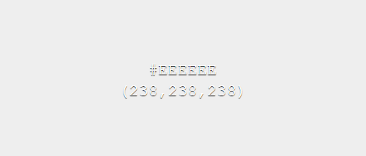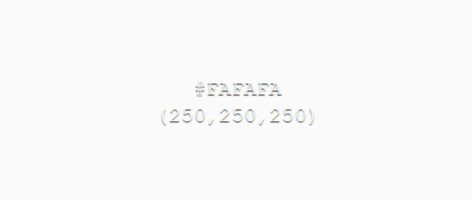

Error, message & action colours

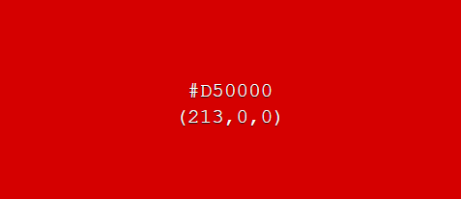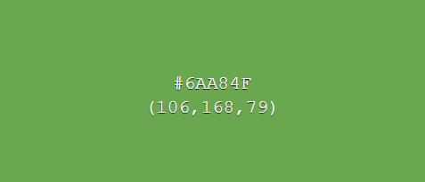

The chosen surface & background colours have been selected as weak toned colours as to not distract the user from more important UI elements. Two variants of the surface & background colours allow contrast between UI elements, such as distinguishing a background of a UI element and the system background, while keeping the same overall theme consistent.

In contrast, error, message and action colour tones have been chosen as bold colours, which draw users’ attention to important information.

GUI Mock-ups

Below are some example mark-up designs for how the system will look and act.

**Login page**

This page will be used by users to login to the system. An option for new users to sign up will also be available.

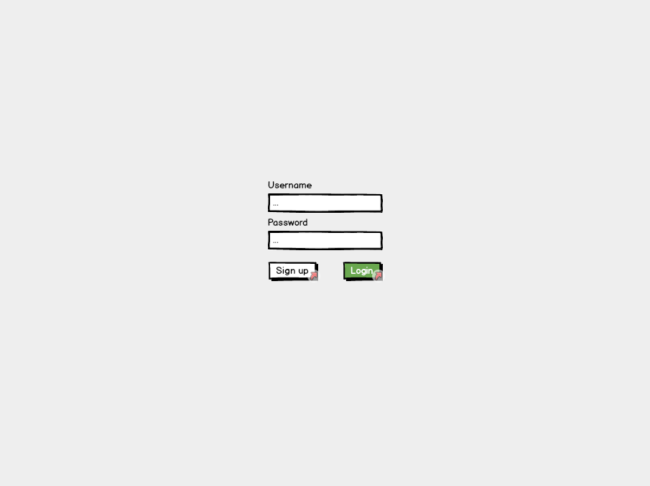

**Sign up page**

The sign-up page will be used by new users to sign up. Any disclaimer texts for users signing up will be displayed here. Users will be required to enter their N number so their account information can be linked with their NTU account.

Incentive for the creation of this page was in case a disclaimer was needed to be signed/read before users were able to use the stores.

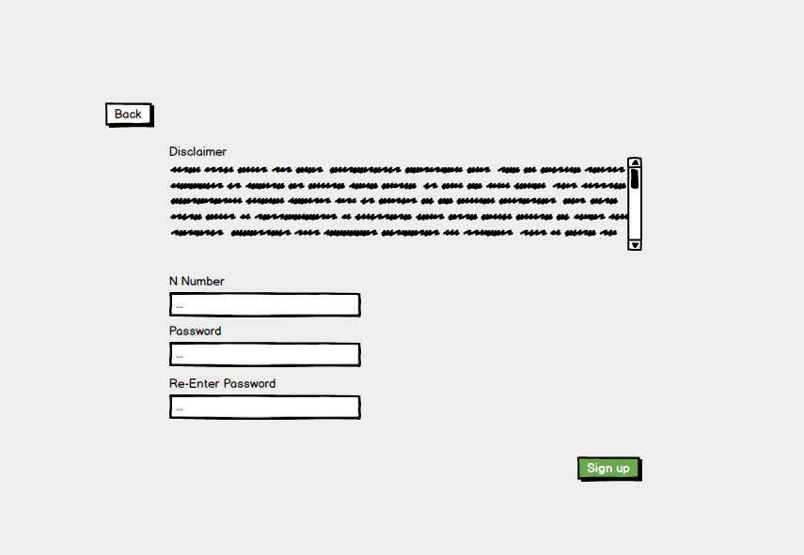

**Products page**

Once signed in users will be navigated to this page. From here products can be selected/searched for. A menu bar at the bottom of the page consistent across many screens will be available for navigating around the system.

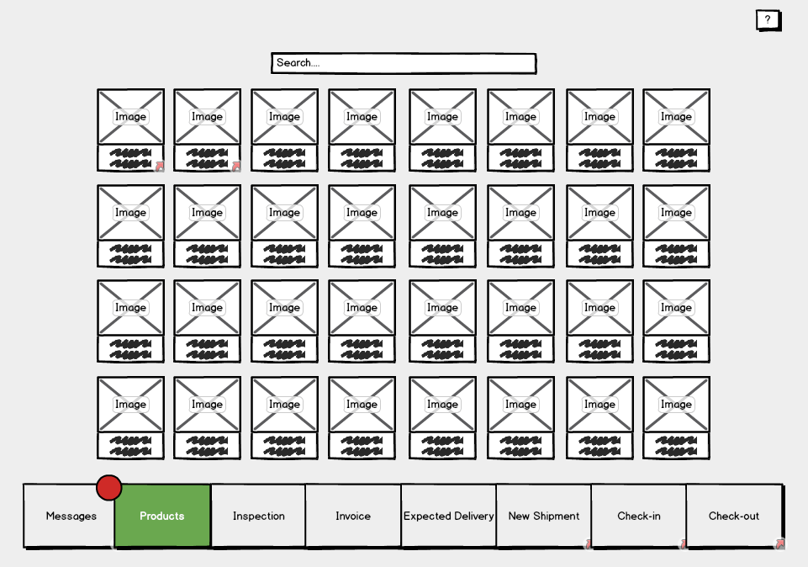

Users, as opposed to staff and admins, have less options and therefore their menu bar will be more simplistic.

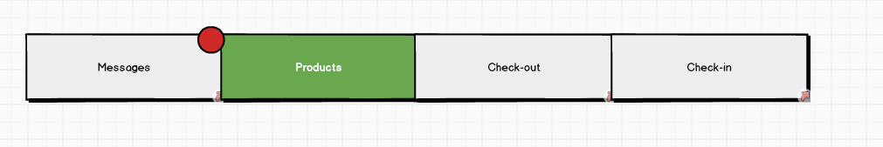

**Single product page**

This page will display the necessary information of a product. From here a user can add a product to their basket to checkout. A map of the location of the product within the store will also be available. If no items of the displayed product type are available users will be notified here as to when, if known, the next shipment of this product is expected.

This page will be navigable from various locations within the software in which products are shown.

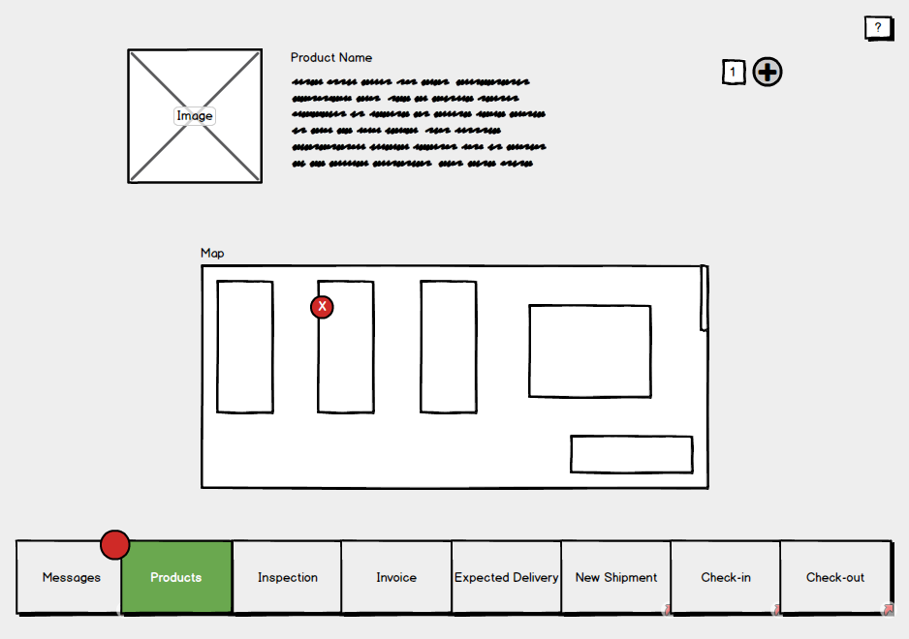

**Single product page (For staff & admins)**

Admins and staff will have access to more features on this page such as the ones shown below. Blue controls represent ones which only admins will be able to use.

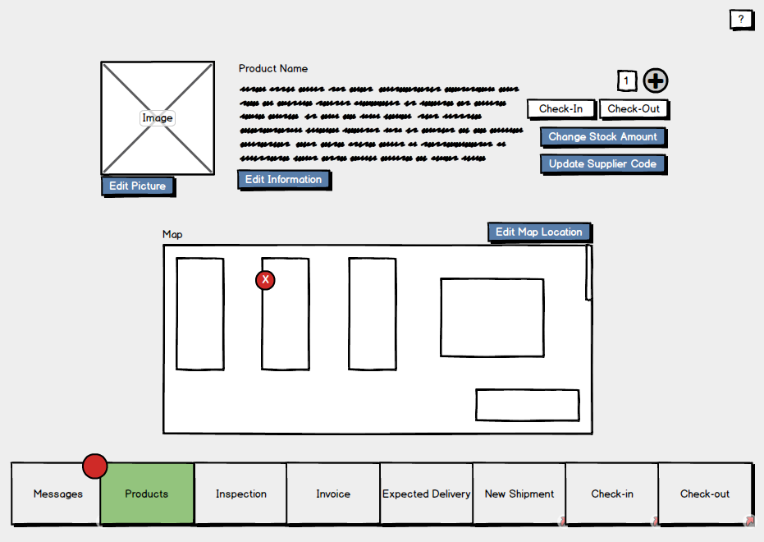

**Check out page**

This will be like a basket page seen on various shopping sites displaying a list of the products which the user wishes to checkout. Users will be able to remove items from this list, check the quality of the items and view their descriptions.

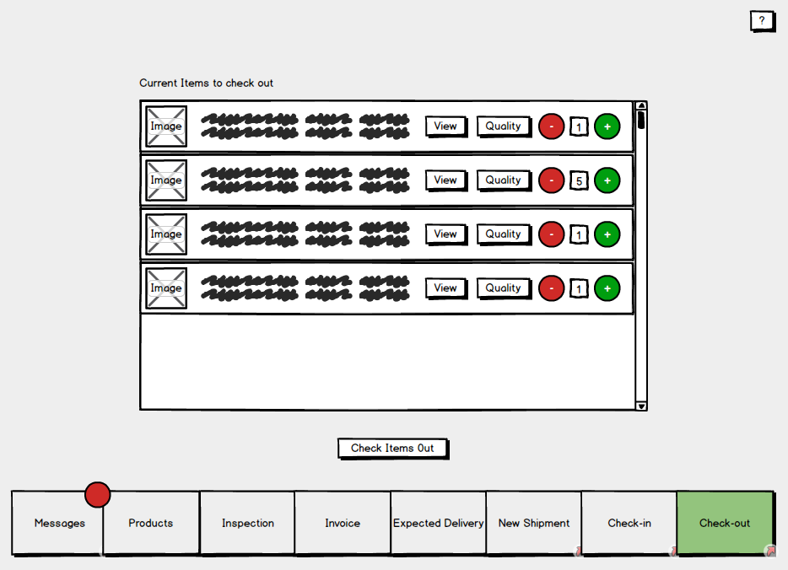

**Check-in page**

On this page staff will be able to search for a customer to see the items they have currently checked out. These items can be selected and checked back in. (This will send them either to the inspection database if it’s developed in time, or flag them as returned in stores)

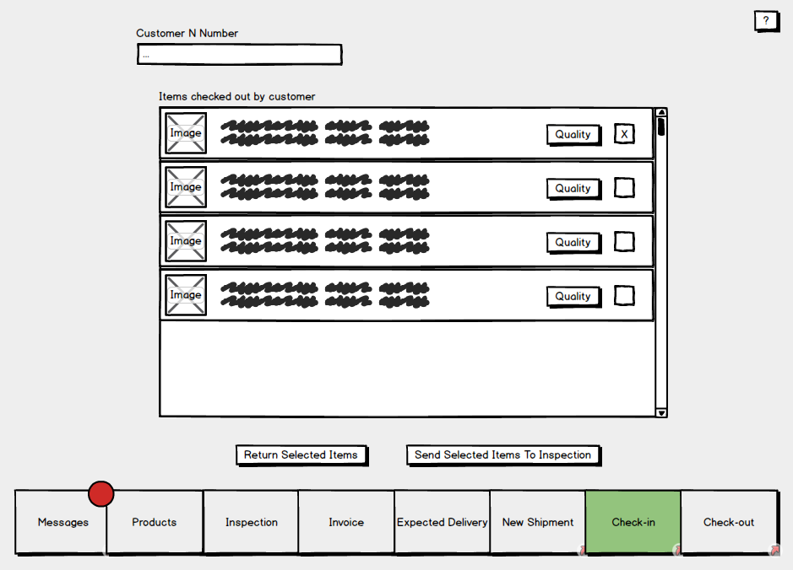

**Messages page**

The messages page will display messages for the logged in user. Categories of messages include; Overdue returns, products low on stock, expected shipments and expiring products.

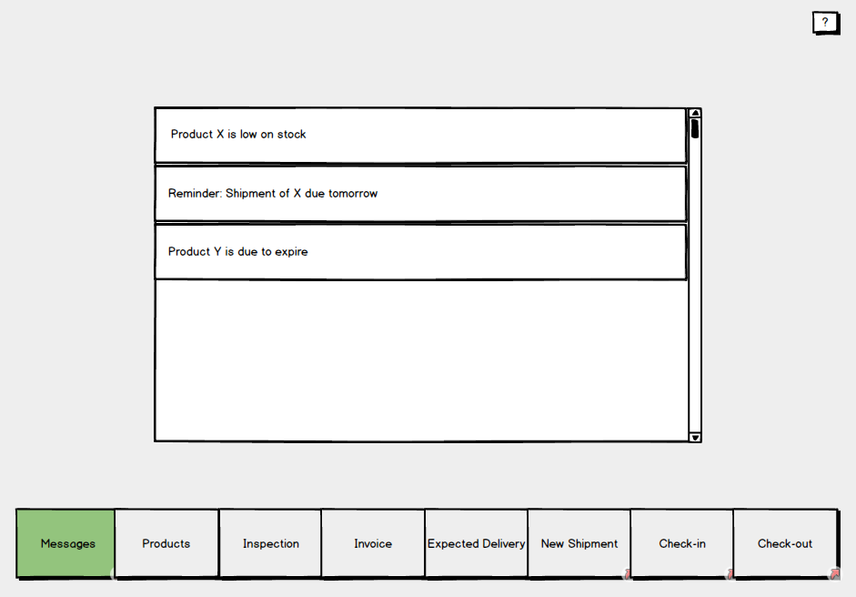

**New shipment pages**

This page, used by staff, is to enter information about an arrived shipment. Depending on weather the shipment is a repeat shipment the user will navigate to either the “Add brand new product” page or “Update stock shipment” page.

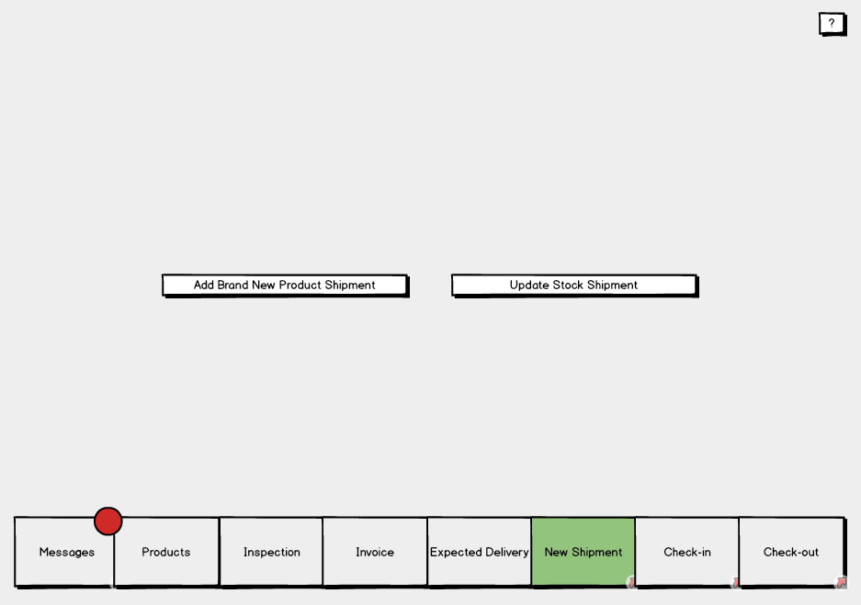

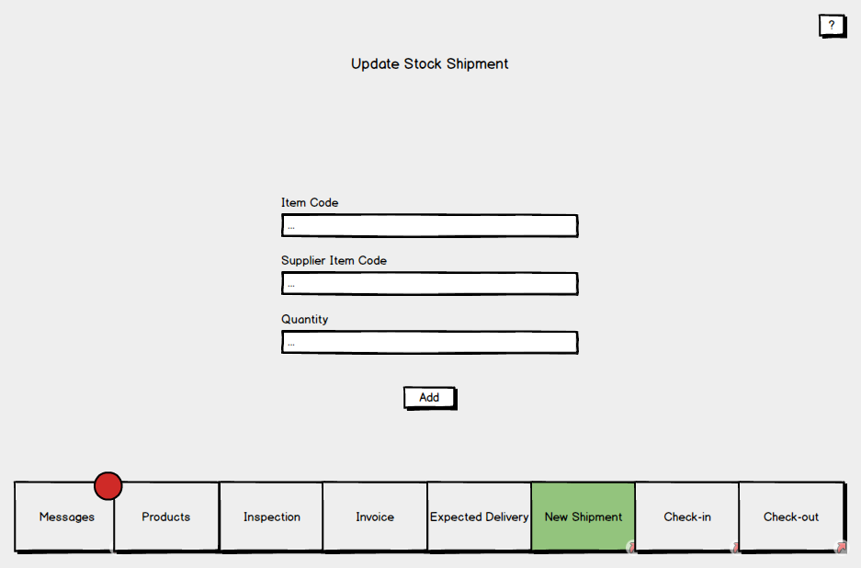

**Adding new shipments**

The process of adding new shipments is to be split up into two separate pages. First where shipment information is entered, and second where the items of the shipment are entered. These items will then be saved to stores.

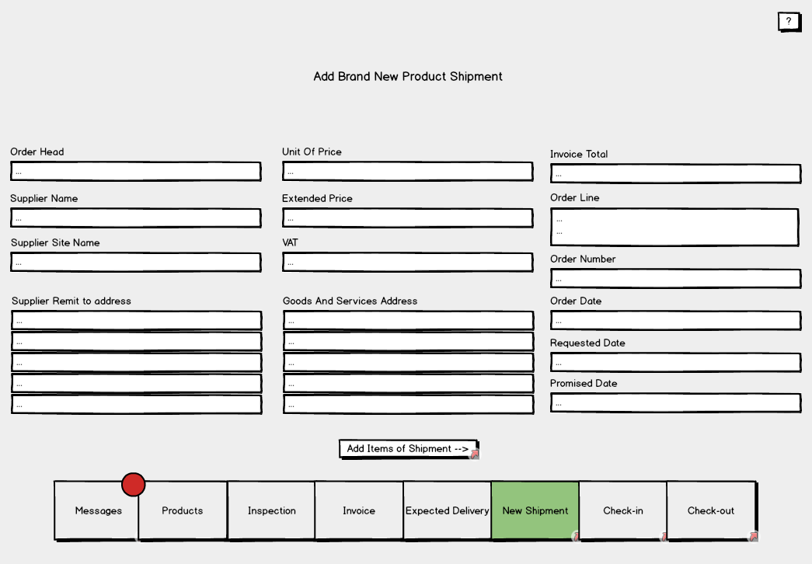

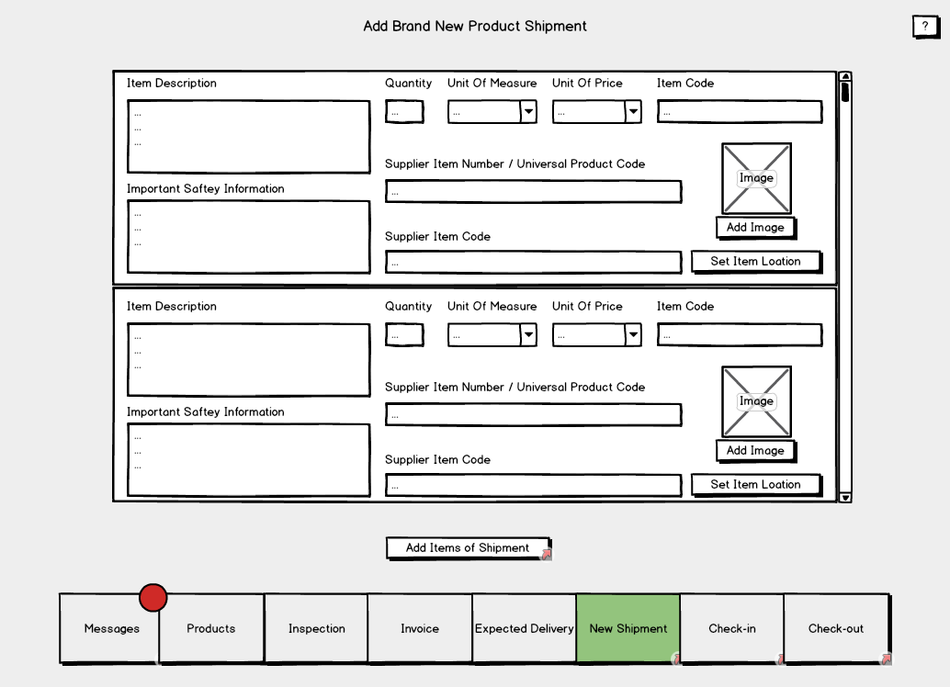

**Invoices page**

Two options are available on this page; A staff member can either add an invoice manually to be sent to a department, or, the invoice information can be filled in automatically from the systems invoice log.

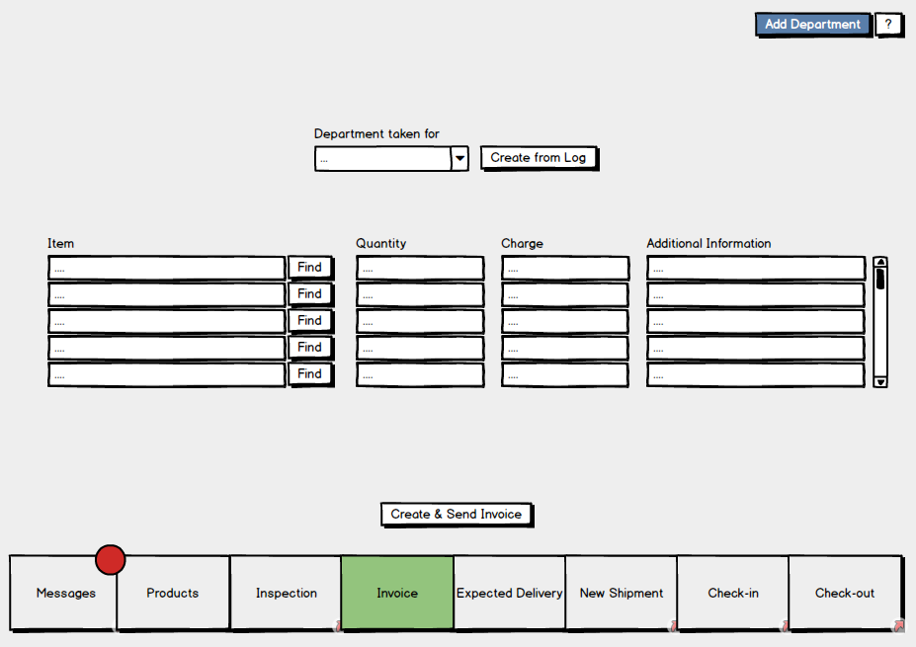

**Inspection page**

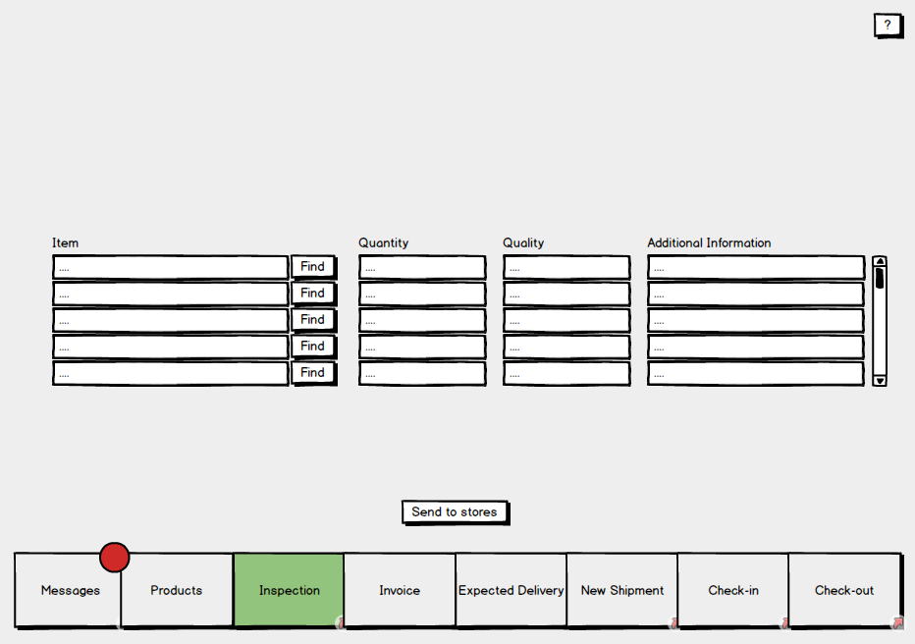

**3.2 Hardware interfaces**

Thanks to the system being software based there are only two hardware interfaces to be considered. Firstly, the systems interface with the barcode scanner, and secondly the interface between the system and computer on which it will run. Both interfaces will be used by staff, admins and customers.

**3.3 Software interfaces**

The diagram below illustrates the systems software interfaces.

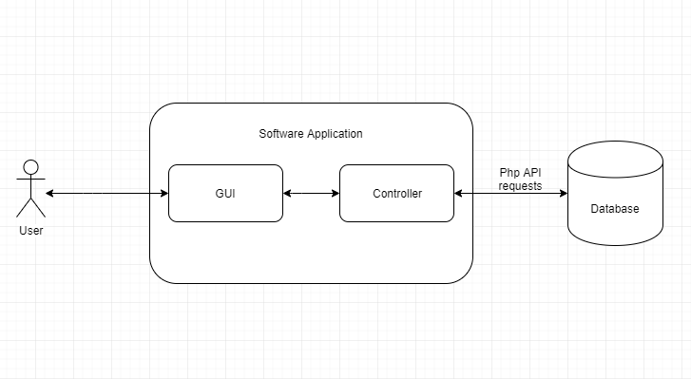

The systems interface with the database will be used to transfer data between the database and the system. This will include the retrieval and uploading of; products, user data, transactions and invoices. In order to achieve its functionality, the interface will make use of the internet via PHP API requests.

The systems backend will be linked via an interface to the GUI. This link will provide the user with a method of accessing the systems features.